Step by step, practical point

* The project is created in Expo using the command “npx create-expo-app@latest” and adding the “--template” statement.



* Template: Blank is selected and the project name App expo is assigned.



* We access our created project with “cd project_name” and execute the line “code .” to open the program

* We create the SRC folder to store the elements of our app Project

- We generate the structure of each of the requested screens and your styles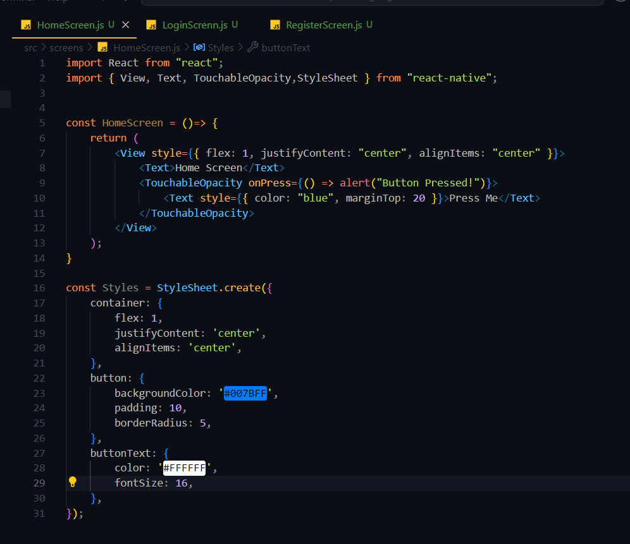

- The AppNavigator.js file is generated to have control over the created screens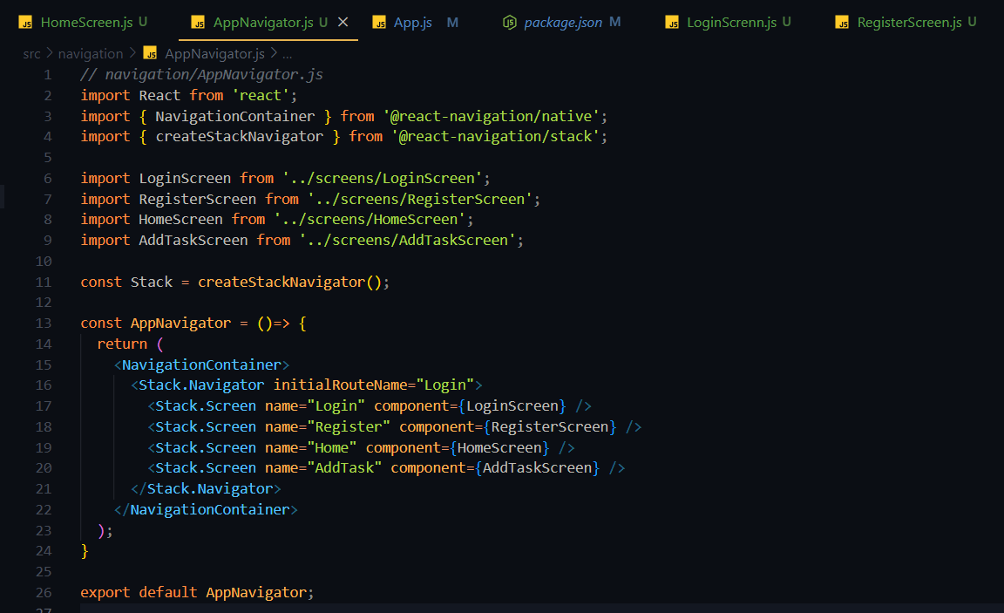

- The “.env” file is created, which contains the information to consume the Firebase API.

- The “firebaseConfig.js” file is created to consume the firebase service in our project



